TASK 1 --

create table shopping_history (

product varchar not null,

quantity integer not null,

unit_price integer not null);

select * from shopping_history;

insert into shopping_history values

('milk',5,20),('apples',2,125),('bread',3,38),('ketchup',2,110),('bread',5,25),('rice',2,28),

('dal',3,106),('rice',3,30),('milk',7,25),('mustardoil',5,125);

select product,sum(quantity * unit_price) as total_price from shopping_history

group by product

order by product desc;

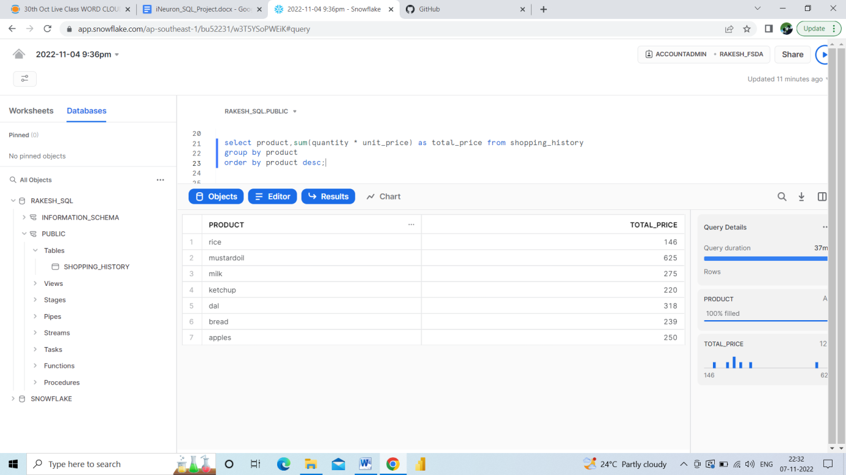

TASK 2 ---

create or replace table phones(

name varchar(30) not null unique,

phone_number integer not null unique);

insert into phones values ('jack',1234),

('lena',3333),

('mark',9999),

('anna',7582),

('john',6356),

('addison',4315),

('kate',8003),

('ginny',9831);

create or replace table calls (

id integer not null unique,caller integer not null,callee integer not null,duration integer not null);

insert into calls values (25,1234,7582,8),

(07,9999,7582,1),

(18,9999,3333,4),

(02,7582,3333,3),

(03,3333,1234,1),

(21,3333,1234,1),

(65,8003,9831,7),

(100,9831,8003,3),

(145,4315,9831,18);

select * from calls;

with call_duration as (

select caller as phone_number, sum(duration) as duration from calls group by caller

union all

select callee as phone_number , sum(duration) as duration from calls group by callee)

select name from phones p join call_duration cd on cd.phone_number = p.phone_number

group by name

having sum(duration) >=10

order by name asc;

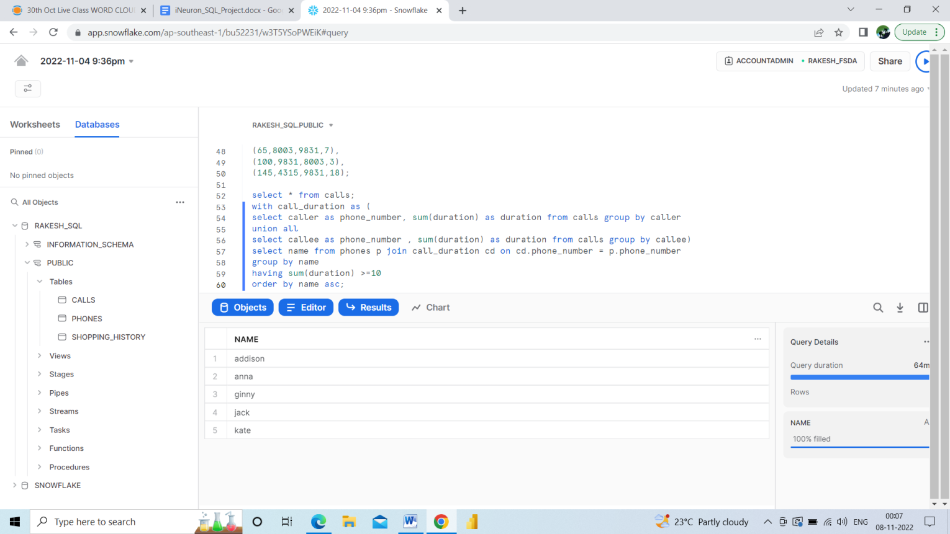

TASK 3—

CREATE or replace table transaction_s(

Amount INTEGER NOT NULL,

Date DATE NOT NULL );

INSERT INTO transaction_s (Amount, Date) VALUES ( 1000, '2020-01-06'), (-10, '2020-01-14'),

(-75, '2020-01-20'),(-5, '2020-01-25'),(-4, '2020-01-29'),

(2000, '2020-03-10'),(-75, '2020-03-12'),(-20, '2020-03-15'),(40, '2020-03-15'),(-50, '2020-03-17'),

(200, '2020-10-10'),(-200, '2020-10-10');

select * from transaction_s;

WITH credit_score AS

(Select M,SUM(AMOUNT)AS Total FROM (Select AMOUNT, MONTH(DATE) AS M FROM transaction_s

WHERE AMOUNT<0 ORDER BY M)

GROUP BY M

HAVING TOTAL<-100

ORDER BY M )

SELECT SUM(AMOUNT)-((12-(SELECT count(*) AS none FROM credit_score))*5) AS BALANCE FROM transaction_s;

